**ID: 20DCE019**

**Name: Yatharth Chauhan**

**Course: CE144**

**Class: DCE-1-A**

**Practical: 1**

**Source Code:**

#include <iostream>

using namespace std;

class Cricketer

{

char name[20];

int age, no_matches;

public:

void get_c()

{

cout << endl;

cout << "Enter name: ";

cin >> name;

cout << "Enter age: ";

cin >> age;

cout << "Enter no. of matches played: ";

cin >> no_matches;

}

void put_c()

{

cout << "Name: " << name << endl;

cout << "Age: " << age << endl;

cout << "No. of matches played: " << no_matches << endl;

}

};

class Bowler : virtual public Cricketer

{

float bow_avg;

int no_wick;

public:

void get_b()

{

cout << "Enter bowling average: ";

cin >> bow_avg;

cout << "Enter total number of wickets: ";

cin >> no_wick;

}

void put_b()

{

cout << "Bowling avg.: " << bow_avg << endl;

cout << "No. of wickets: " << no_wick << endl;

}

};

class Batsmen : public virtual Cricketer

{

float bat_avg;

int runs;

public:

void get_ba()

{

cout << "Enter batting average: ";

cin >> bat_avg;

cout << "Enter total number of runs: ";

cin >> runs;

}

void put_ba()

{

cout << "Batting avg.: " << bat_avg << endl;

cout << "No. of runs: " << runs << endl;

}

};

class Allrounder : public Bowler, public Batsmen

{

};

int main()

{

Allrounder a[5];

int i;

for (i = 0; i < 5; i++)

{

a[i].get_c();

a[i].get_b();

a[i].get_ba();

}

for (i = 0; i < 5; i++)

{

a[i].put_c();

a[i].put_b();

a[i].put_ba();

}

cout << "20DCE019" << endl

<< "Yatharth Chauhan" << endl;

return 0;

}

**Output:**

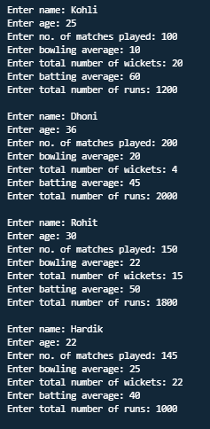

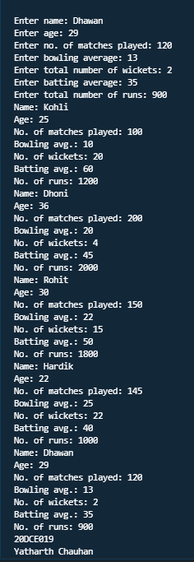

**Practical: 2**

**Source Code:**

#include <iostream>

#include <fstream>

#include <string.h>

#include <cstdlib>

using namespace std;

int main()

{

int noc = 0, now = 0, nol = 0;

FILE *f;

char fname[20], ch;

cout << "\nEnter Source File Name : ";

gets(fname);

f = fopen(fname, "r");

if (f == NULL)

{

cout << "\nInvalid File Name. \n No such File or Directory ";

exit(0);

}

ch = fgetc(f);

while (ch != EOF)

{

if (ch != ' ' && ch != '\n')

noc++;

if (ch == ' ')

now++;

if (ch == '\n')

{

nol++;

now++;

}

ch = fgetc(f);

}

fclose(f);

cout << "\nTotal No. of Characters: " << noc;

cout << "\nTotal No. of Words: " << now;

cout << "\nTotal No. of Lines: " << nol;

return 0;

}

**Output:**

